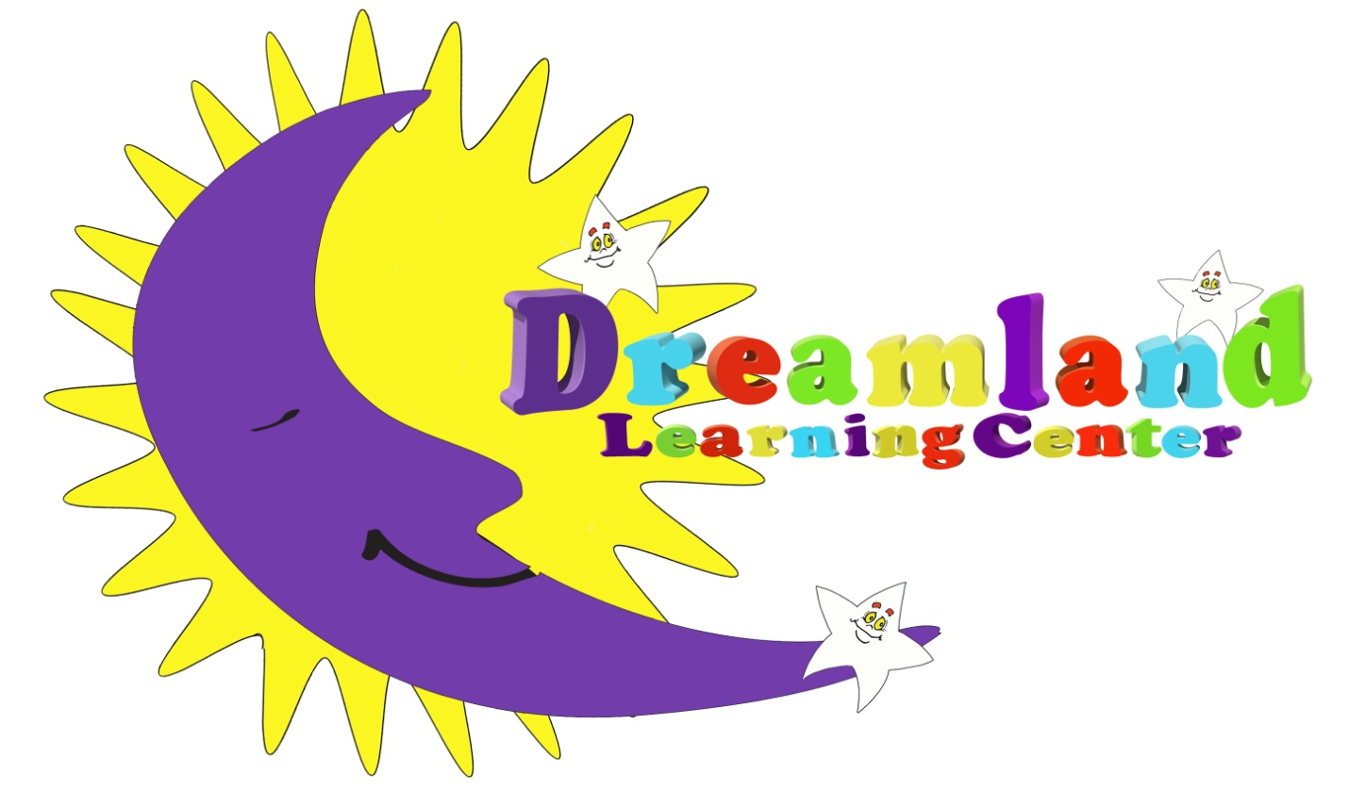

**Enrollment Application**

**Infant/Toddler/Preschool**

***To be completed by parent/guardian and returned to Dreamland prior to first day of care.***

***DAYCARE CENTER***

***PARENT AUTHORIZATION FOR EMERGENCY TREATMENT***

________________________________________________________________________

**Name of Child**

should an emergency arise at Dreamland Learning Center or on a field trip, it is understood that a conscientious effort will be made by Dreamland Learning Center staff members to contact me at the emergency numbers I have provided before any medical action is taken.

I would prefer to have my child taken to the following hospital if the need arises:

________________________________________________________________________

**Name of Hospital**

I understand that choice of hospital may be limited by service of local rescue squad.

_______________________________________ _______________ _______________

**Signature-Mother/Guardian Cell Phone Work Phone**

_______________________________________ ______________ _________________

**Signature-Father/Guardian Cell Phone Work Phone**

**Health Insurance Plan _____________________________________________________________________**

**Policy Number __________________________________________________________________________**

**\*\*\*\*\*\*\*\*\*\*\*\*\*\*\*\*\*\*\*\*\*\*\*\*\*\*\*\*\*\*\*\*\*\*\*\*\*\*\*\*\*\*\*\*\*\*\*\*\*\*\*\*\*\*\*\*\*\*\*\*\*\*\*\*\*\*\*\*\*\*\*\*\*\*\*\*\*\*\*\*\*\*\*\*\*\*\*\*\*\***

Relatives or other persons to be contacted in an emergency

**Name _______________________ Name __________________________**

**Phone Number ________________ Phone Number __________________**

**Relationship to child ___________ Relationship to child _____________**

**Today’s Date___________________________**

Enrollment Date

____/____/____

Enrollment Status

Full Time

or

Part Time

MCj03979950000%5b1%5d

Client Information

# Child’s Name________________________________ D.O.B.__________

Parent/Guardian Information

# Mother/ Guardian’s Name _________________________ D.O.B.___/___/___

Home Address ____________________________________City__________________Zip__________

Home Phone _______________ Cell Phone_______________ E-Mail___________________________

Employer Name ____________________________ Work Address______________________________

Work Phone _________________ Hours at work ____ to ____ Days at work______________________

# Father/ Guardian’s Name _________________________ D.O.B.___/___/___

Home Address ____________________________________City__________________Zip__________

Home Phone _______________ Cell Phone_______________ E-Mail___________________________

Employer Name ____________________________ Work Address______________________________

Work Phone _________________ Hours at work ____ to ____ Days at work______________________

**Persons authorized for pickup:**

Name_____________________________ Relation to child________________ Phone___________________

Name_____________________________ Relation to child________________ Phone___________________

Name_____________________________ Relation to child________________ Phone___________________

Name_____________________________ Relation to child________________ Phone___________________

Name_____________________________ Relation to child________________ Phone___________________

Name_____________________________ Relation to child________________ Phone___________________

**In case of emergency please contact one of the following if a parent/guardian cannot be reached:**

Name_____________________________ Relation to child________________ Phone___________________

Name_____________________________ Relation to child________________ Phone___________________

Name_____________________________ Relation to child________________ Phone___________________

Get Acquainted Record

My nickname is: ________________________________________________________

I have ____ brothers & ____ sisters, their names and ages are: ___________________

______________________________________________________________________

My favorite activity is: ______________________________________________________________________

My favorite toy is: ______________________________________________________________________

My favorite food is: ______________________________________________________________________

My least favorite food is: ______________________________________________________________________

Due to your child’s tastes, allergies, reactions, and/or religious beliefs, are there any foods which should not be served to your child? ______________________________________________________________________

Please list these foods: __________________________________________________________________________________________________________________________________________________________________________________________________________________

Does your child feed themselves? __________________________________________

Does he/she enjoy eating? ________________________________________________

Is your child usually hungry at meal time?__________ In between meals?___________

What time does your child typically go to sleep and wake up each day?

______________________________________________________________________

How does your child go to sleep?

______________________________________________________________________________

Are there any special dolls or toys he/she needs in order to go to sleep?

______________________________________________________________________

Please list any personal habits, thumb sucking, nail biting, ect.

____________________________________________________________________________________________________________________________________________

Is your child in diapers or Pull-Ups? _________________________________________

Has potty training begun? _________________________________________________

Can your child be relied on to indicate that he/she needs to use the bathroom?

______________________________________________________________________

Are there specific bathroom words used?

______________________________________________________________________

Does your child have any fears? If so, please list them. ______________________________________________________________________

Has your child had previous day care experience?

____________________________________________________________________________________________________________________________________________

How does your child respond to new people?

__________________________________________________________________________________________________________________________________________________________________________________________________________________

What type of discipline is used at home?

____________________________________________________________________________________________________________________________________________

Does your child have any behavior issues/ problems that you are concerned with?

____________________________________________________________________________________________________________________________________________

What are your main expectations of this program?

________________________________________________________________________________________________________________________________________________________________________________________________________________________________________________________________________________________

**ALLERGY INFORMATION**

|  |  |  |  |  |  |  |  |  |  |  |
| --- | --- | --- | --- | --- | --- | --- | --- | --- | --- | --- |
|  | **Child’s Information** | | | | | | | (Check if allergic) | | |
| **MAY** Be exposed | | May ***NOT*** be exposed | ***IS*** allergic | Is ***NOT***  allergic | Not Sure | | Parent(s) | | Other Family Member |
| **Foods:** | | | | | | | | | | |
| Peanuts |  | |  |  |  |  | |  | |  |
| Other nuts & seeds |  | |  |  |  |  | |  | |  |
| Citrus fruits |  | |  |  |  |  | |  | |  |
| Other fruits |  | |  |  |  |  | |  | |  |
| Cow’s milk |  | |  |  |  |  | |  | |  |
| Yogurt |  | |  |  |  |  | |  | |  |
| Other dairy |  | |  |  |  |  | |  | |  |
| Corn |  | |  |  |  |  | |  | |  |
| Oats |  | |  |  |  |  | |  | |  |
| Wheat |  | |  |  |  |  | |  | |  |
| Other grains |  | |  |  |  |  | |  | |  |
| Yeast |  | |  |  |  |  | |  | |  |
| Egg yolks |  | |  |  |  |  | |  | |  |
| Egg whites |  | |  |  |  |  | |  | |  |
| Soy foods |  | |  |  |  |  | |  | |  |
| Fish |  | |  |  |  |  | |  | |  |
| Shell fish |  | |  |  |  |  | |  | |  |
| **Environmental:** | | | | | | | | | | |
| Dust |  |  | |  |  |  |  | |  | |
| Mold spores |  |  | |  |  |  |  | |  | |
| Cats |  |  | |  |  |  |  | |  | |
| Dogs |  |  | |  |  |  |  | |  | |
| Other animals |  |  | |  |  |  |  | |  | |
| Pollen |  |  | |  |  |  |  | |  | |
| Bee stings |  |  | |  |  |  |  | |  | |
| **Medical:** | | | | | | | | | | |
| Penicillin |  |  | |  |  |  |  | |  | |
| Latex |  |  | |  |  |  |  | |  | |
| **Other (please list):** | | | | | | | | | | |
|  |  |  | |  |  |  |  | |  | |
|  |  |  | |  |  |  |  | |  | |
|  |  |  | |  |  |  |  | |  | |
|  |  |  | |  |  |  |  | |  | |

***Handwashing Guidelines***

Dreamland Learning Center will enforce the following handwashing guidelines for all children and staff:

* All children and staff volunteers should engage in hand hygiene at the following times:
  + Arrival to the facility and after breaks (Hand Sanitizer will be provided in our front lobby)
  + Before and after preparing food or drinks
  + Before and after eating or handling food, or feeding children
  + Before and after administering medication or medical ointment
  + Before and after diapering
  + After using the toilet or helping a child use the bathroom
  + After coming in contact with bodily fluid
  + After playing outdoors or in sand
  + After handling garbage
* Wash hands with soap and water for at least 20 seconds. If hands are not visibly dirty, alcohol-based hand sanitizers with at least 60% alcohol can be used if soap and water are not readily available.
* Supervise children when they use hand sanitizer to prevent ingestion.
* Assist children with handwashing, including infants who cannot wash hands alone.
  + After assisting children with handwashing, staff should also wash their hands.
* Place [posters](https://www.cdc.gov/handwashing/posters.html) describing handwashing steps near sinks.

**Child Illness Policy**

**\*UPDATED SICK POLICY\***

Policies and guidelines related to outbreaks of communicable diseases and illnesses in this facility have been developed with the help of the local health department and CDC in order to protect the group as well as the health of each child. We ask that parents assist us by keeping sick children at home. If they have experienced any of the following symptoms **in the past 72 hours** they will not be accepted into the center.

* **A fever of 100.4**
* **Cough**
* **Shortness of breath or difficulty**
* **Body aches**
* **Chills**
* **Sore Throat**
* **Diarrhea**
* **Vomiting**
* **Unusual or unexplained loss of appetite, fatigue, irritability, or headache.**
* **Any discharge or drainage from the eyes, nose, ears, or open sores.**

**If in the last 14 days:**

* Someone in your household was diagnosed with COVID-19
* Have been told to quarantine yourself by any public health authority
* Have been in close contact with someone who has tested positive for COVID-19
* Have traveled anywhere outside of the 50 States or on a cruise
* Have traveled anywhere in the United States by commercial airlines

Please contact our center prior to dropping off your child.

Additionally, children may not attend the center if they have live lice or if they show any other signs or symptoms that limit the staff’s ability to provide an acceptable level of child care and may compromise the health and safety of the children.

Children who show signs or symptoms listed above will be sent home as soon as possible. Children must be picked up **NO LATER THAN ONE HOUR** of the first phone call. The child will remain isolated with an adult until pick-up.

If a child is sent home he/she will be placed in our center’s isolation room, which is our back office, with a staff member. Once the child is sent home, a cleaner will clean and disinfect surfaces in our isolation room.

If your child is sent home with any of the symptoms explained above, he/she may not return to daycare they are completely free of symptoms **for 72 hours.** Documentation should be provided whenever your child has any communicable illness so that we may track and report cases as needed.

I have read and understand this policy.

______________________________________ _________________

Parent Signature Date

***NOTE: Your child will still need to be picked up within one hour. This will simply provide comfort to both you and your child that he/she is being kept as comfortable as possible.

***We ask for your patience and understanding while we attempt to implement this procedure to enforce social distancing.***

I have read and understand this procedure

______________________________________ _________________

**Drop-Off and Pick-up Procedure:**

1. Parent will be mandated to ring the doorbell at the front door. The administrator will answer through the intercom to notify the parent that they will unlock the door to enter the lobby or clear then to scan their key to enter the building. Parents will do this by waving their key over our scanner at a distance, there will be no contact. If the administrator is already assisting a parent in the lobby, the administrator will advise the parent waiting outside to sit back in their car until the other exits the building.
2. Once the parent enters the lobby, the parent and child will utilize our hand sanitizer provided in our lobby. Then the administrator will facilitate the COVID-19 screening tool for the adult and child through the office communication window.
3. If the parent and child pass completed screening tool, our infrared system will scan the child and adults body temperature separately and notify the administrative staff the temperature of both persons to our system.
4. Once the child is cleared to join the program, the administrator will open the office door for the child to enter the office and transition to the administrator supervision as the parent leaves the building. The administrator will bring each child to their designated classroom.
5. The same procedure will be followed for staff.
6. For pick-up step 1 will be followed and the administrator will get the child from the classroom and release the child to the parent from the office.
7. The administrator will manually sign-in or out all children and staff on their computer.

**Drop-Off Time Slots:**

Drop off will begin when we open at 8:00 am and end at 10:00 am. Below are the time-slots parents will choose for consistent and separated drop off:

_ 7:00 am _7:06 am _ 7:12 am _7:18 am _7:24 am _7:30 am _7:36 am _7:42 am _7:48 am _ 7:54 am _ 8:00 am _8:06 am _ 8:12 am _8:18 am _8:24 am _8:30 am _8:36 am _8:42 am _8:48 am _ 8:54 am _9:00 am _9:06 am _9:12 am _9:18 am_9:24 am _9:30 am _ 9:36 am _9:42 am _9: 48 am _9:54 am _ 10:00 am

**Pick-Up Time Slots:**

Pick-Up off will begin at 3:00 pm and end at 5:00 pm. Below are the time-slots parents will choose for consistent and separated drop off:

_ 3:00 pm _3:06 pm _ 3:12 pm _3:18 pm _3:24 pm _3:30 pm _3:36 pm _3:42 pm _3:48 pm _ 3:54 pm _4:00 pm _4:06 pm _4:12 pm _4:18 pm

_4:24 pm _4:30 pm _ 4:36 pm _4:42 pm _4: 48 pm _4:54 pm _ 5:00 pm _5:06 pm _5:12 pm _5:18 pm _5:24 pm _5:30 pm

**Permission to Administer**

Tylenol/Motrin

Your child may develop a fever while here at Dreamland. We will **ALWAYS** make every attempt to reach you immediately. In the event that we are unable to reach you for verbal confirmation, this form will allow us to administer fever reducing medicine until your child is able to be picked up. If you would like us to receive verbal confirmation from you before administering, please indicate so.

Child's Name: _________________________________________________________________

Child's Date of Birth: ___/___/_____ Weight: ______

I hereby give **ALL STAFF AT DREAMLAND LEARNING CENTER** permission to administer one or more of the following products, in accordance with the directions for use on the container.

Infant’s Tylenol ___yes ____ no ____ upon verbal consent only

(Aspirin free pain reliever and fever reducer)

Children’s Tylenol

(Aspirin free pain reliever and fever reducer) ___yes ____ no ____ upon verbal consent only

***NOTE Please provide a bottle of your preferred fever reducer to be kept here for use as needed. The bottle must be clearly labeled with the child’s name and have the appropriate dosage cup or syringe.

I, _____________________________________________________________, release **ALL STAFF AT DREAMLAND LEARNING CENTER** from any liability for administering these medications.

Parent's / Guardian's Signature ________________________________Date ___/___/____

**Infant Feeding Schedule**

|  |  |  |  |
| --- | --- | --- | --- |
| **Time** | **Formula/ amount** | **Cereal/amount** | **Food/**  **jarred/solids/amount** |
|  |  |  |  |
|  |  |  |  |
|  |  |  |  |
|  |  |  |  |
|  |  |  |  |
|  |  |  |  |
|  |  |  |  |

Do you have any preference as to how or when new foods are introduced?

**Sleep schedule**

|  |  |  |
| --- | --- | --- |
| **Time** | **How long?** | **Special nap routine** |
|  |  |  |
|  |  |  |
|  |  |  |

Permission to Administer

Orajel/Teething Relief

This form will allow us to administer Orajel/Teething Gels on an as-needed basis to your child without daily written consent. If you would like us to receive verbal consent from you each time please indicate so.

Child's Name: _________________________________________________________________

Child's Date of Birth: ___/___/_____ Weight: ______

I hereby give **ALL STAFF AT DREAMLAND LEARNING CENTER** permission to administer one or more of the following products, in accordance with the directions for use

on the container.

Baby Orajel ___yes ____ no ____ upon verbal consent only

(Teething Relief Gels, Tablets etc.)

Other: __________________ ___yes ____ no ____ upon verbal consent only

***NOTE Please provide a bottle of your preferred medication for use on an as-needed basis.

I, _____________________________________________________________, release, **ALL STAFF AT DREAMLAND LEARNING CENTER**, from any liability for administering these medications.

Parent's / Guardian's Signature ________________________________Date ___/___/____

**DREAMLAND DISCIPLINE POLICY**

The goal of Dreamland Learning Center is to provide a positive, caring environment which will help to nurture the growth, development and socialization of your child. The staff, together with the children, will decide on classroom rules.

There will be no harsh, cruel, or unusual treatment of children in the center. There will be no corporal punishment or threats of corporal punishment. Children will never be shaken, bitten, hit with hands or instruments, pinched, or have anything put in mouth as punishment. Children will never be humiliated, shamed, ridiculed, rejected, or spoken to harshly, abusively, or with profanity.

When a discipline problem occurs we will follow this procedure in order to find a workable solution.

1. Contact parents and discuss the situation, work together on a positive solution and obtain parental support. Incidents as they occur will be documented on an Incident Report form.
2. If the situation does not improve, the parents will be contacted requesting a conference. Events since the first discussion will be reviewed and alternative solutions will be explored.
3. If the inappropriate behavior continues, permanent dismissal from the program may result.

I have read and understand the above policy.

SIGNATURE ___________________________ DATE ____________

***Child Abuse Policy***

The State of Rhode Island requires that suspected cases of child abuse and/or neglect be reported to the Department of Children, Youth and Families (DCYF) immediately following suspicions. Failure to do so will result in a hearing, a fine for staff person and/or possible loss of licensure for Dreamland Learning Center.

It is the responsibility of all persons to report suspicions of abuse or neglect. It is not our responsibility to determine if abuse or neglect has occurred. Dreamland Learning Center will not undertake the responsibility to determine if abuse or neglect has occurred. Dreamland Learning Center will not undertake the responsibility to treat cases of a child’s abuse and/or neglect on their own.

Abuse is defined in three (3) basic ways:

1. **Physical Abuse** is when bruises, burns, broken bones, etc., appearing on the child present substantial risk of harm to the child.

2. **Emotional Abuse** may include repeated name-calling, scape-goating, and/or put-downs.

3. **Neglect** is the lack of basic adequate attention to the home, food, clothing, health care, and the personal hygiene of the child.

All staff is responsible for carefully documenting and monitoring any cases of suspected child abuse and/or neglect. All suspected cases are reported to the director as soon as possible.

Staff is given information regarding this procedure at a pre-service orientation. Staff members are encouraged to attend workshops on this matter throughout the program year.

The purpose of the protocol is to protect the children and to prevent further abuse or neglect, not to punish the parents.

Parent/Guardian Signature

**Rate/Payment Policy**

Tuition for childcare service is based on a weekly rate. The agreed upon fee remains constant regardless of holidays, snow closings, early release days due to inclement weather, if your child does not attend due to illness, and personal vacations.

Tuition is due on the Friday before or the Monday of each week for the upcoming week. If payment amounts are overdue by two weeks, childcare services may be suspended until a payment is made and the balance due is up-to-date. Repeated late tuition payments may jeopardize your child care services.

Families who receive subsidized child care through the Department of Human Services are responsible to keep their own case up-to-date. If there is a lapse of approval from the Department of Human Services for the child care services, parents will be responsible to pay for these services.

**Non-payment policy-** In the event that you remove your children without notice you will be billed for two week’s tuition. Your balance must be paid in full within 30 days. Past due balances will incur a $25.00 late fee for each week of non-payment. After 30 days of non-payment, your account will be placed in collections. You will be responsible for any legal fees and collection fees incurred.

________________________________ _________________

Parent/Guardian Signature Date

Lunch Options

At Dreamland you have the option to either provide your own prepared, peanut-free lunch, or purchase our school lunch for $4.20 per day ($16weekly). This meal plan includes breakfast, am snack, lunch, pm snack and milk. The cost will be added to your tuition.

Should you choose to provide lunch for your child, it must meet the USDA food requirements as presented below. It also must be nut free and prepared/ready to eat. We are unable to heat up/prepare food sent from home. You may send warm food in a thermos and pack an ice pack to keep things cold. We cannot keep any items in the refrigerator. All lunch boxes must be labeled with the child’s first and last name.

If the school is closed for a holiday or snow day, we will prorate the weekly lunch charge accordingly. These options apply for DHS as well as cash paying families. If you choose to bring your child lunch, and you forget to send them one, we will feed them our lunch and your account will be charged $6.60 for that day.

Child’s Name: _____________________________________________

Allergies: _________________________________________________

______ I will be participating in the meal plan that Dreamland will provide for $4.20 per day. I understand that this will be charged to my account weekly similarly as tuition and copays are charged. Payments will be due the Friday before the following week.

______ I will not be participating in the meal plan. I will be providing lunch for my child from home. I understand that the food sent from home must meet the USDA food requirements provided below. I understand that these meals must be peanut-free and prepared/ready to eat. We are unable to heat-up/prepare food sent from home.

Parent Signature _________________________________ Date ___________

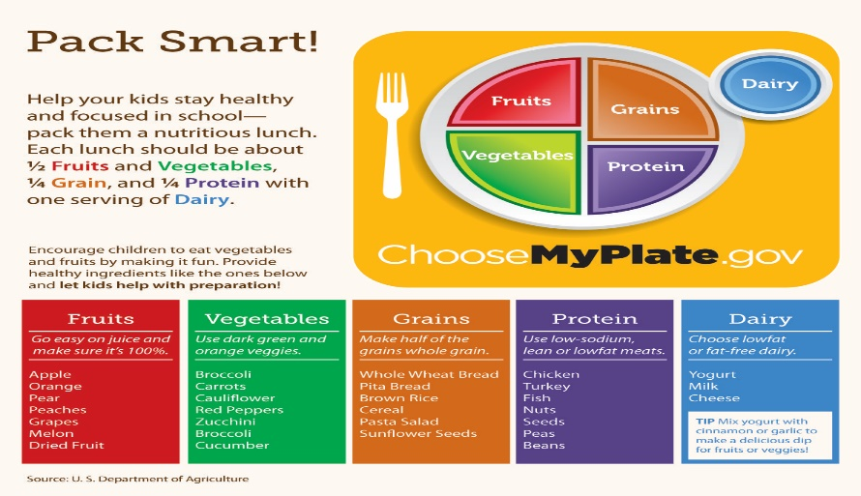

**Child Care Enrollment Agreement**

Child’s Name: _________________________________________________

Hours Attending: ________________________________________

Weekly Tuition Rate: _____________________________

***I AGREE (TO):*** (place initials on each line)

____ adhere to my child’s pre-determined weekly schedule and hours.

____ pay my child’s tuition on Friday or Monday for the upcoming week.

____ that if I become two weeks behind on my payment of weekly tuition, my child’s enrollment may be terminated at the discretion of the director.

____ that if my child is absent for two consecutive weeks, her/his child care slot may be terminated at the discretion of the director.

____ that the tuition rate is based on a pre-determined schedule and remains constant even when there are holidays, snow closings, child illness or family vacations (unless otherwise indicated by the director).

____ provide up-to-date health forms for my child supplied by my child’s doctor. I understand that I may obtain blank medical forms from the director. I also understand that my child’s enrollment may be terminated if I fail to submit the necessary health forms.

____ provide an up-to-date list of emergency contacts and names of those people my child may be released to.

____ give a two week notice in writing when I am no longer in need of Dreamland Learning Center’s services.

____ allow for my child to participate in field trips with prior notification.

____ allow for photographs to be taken of my child for use within the classroom as well as for press and advertisement purposes.

____ understand the first two weeks of enrollment are considered an assessment period designated to evaluate how the program can best meet my child’s needs.

____ allow Dreamland to take my child to the nearest hospital should an emergency arise which warrants this. I am aware that I will be notified first. However, if reasonable efforts have been made to contact me, and I was unable to be reached, I do give my permission to the staff to take necessary action to ensure my child’s safety and well-being.

____ if my child has to be transported to any medical facility, all of her/his medical information on file at Dreamland will be taken with my child and released as necessary.

____ understand that Dreamland, in arranging for transfer of my child to a nearest appropriate medical facility for emergency care, is acting as a medium of mercy and is not, thereby, assuming responsibility.

____ that I was notified of Dreamland Child Abuse and Neglect Policy.

____ that I understand all information I provide will remain strictly confidential. However, the limits to confidentiality end in cases of suspected child abuse or neglect or if someone’s life/well-being is threatened.

____ contact Dreamland if my child is not attending school for any reason.

____ provide all necessary items for my child’s daily comfort.

____ comply with the overall policies and procedures mentioned throughout the handbook.

***SUNSCREEN (Choose one)***

____ I will put sunscreen on my child(ren) before he/she attends school.

____ I will not put sunscreen on my child before he/she attends school. Therefore, I give permission for Dreamland staff to put sunscreen on my child. I will supply Dreamland with sunscreen for my child.

____ My child is not to have sunscreen put on her/him while at Dreamland.

_________________________________________ ________________________

**Parent/Guardian Signature(s) Date**

**_________________________________________ ________________________**

**Director Signature Date**

**Tuition Rates**

*** A one-time registration fee of $50 is due at the time of registration***

Infant/Toddler Tuition = $240

Preschool Tuition = $210

8.5 hours or more per day- $1.00 per Minute over

**(This includes cash and DHS clients).**

On any given day, if your child is here for more than 8.5 hours, you will be billed separate at a rate of $1.00 per minute for that day.

Tuition is based on a weekly basis. If tuition payments fall more than two weeks behind, child care services may be subject to termination.

_______________________ ______________

Parent/Guardian Signature Date

_____________________ _____________

Director Signature Date

